**Individual report**

For this task, we were given a video link that we had to follow in order to create our own Lego figure using 3DS Max software in my Tutorials as a part of my group project. Once started and completed our first Lego figure the we had to come up with our own idea to create different Lego figure which will be a part of our group project with unique textures.

The Lego figure I created in the tutorials also includes animation of legs and arms which then later be exported to unity software to make the scenery.

My group has decided to go with the idea of a Car, this will include building a car, first and 3rd person viewing, one Lego figures, one vehicle and changing background etc changing the background to day and night. The idea is to allow users to change viewing angle with a mouse interactivities and also change the background with 2 to 3 camera angles. The car will also allow user to switch on/off the lights and also it will be time base. We wanted to make the project have interactivity and navigation, which is why we decided to implement some features, such as, mouse orbit to move around the object and see it from different directions, a pop-up menu which will have set keys for actions and can be used to start each individual animation separately and more. Our group have also uploaded a PowerPoint presentation to give a brief idea on the content of the project and screenshots relating to how the finalised project will look like. In the PowerPoint I have also Demonstrated my progress of the Lego figure model.

As a group We decided that the best way to share the workload was to allow each member to choose what part then going to work on and also the implantation all of the group member will work together. We have also set up online share document, where we will share all over file with other members to get the feedback on the file / modelling we have created. As a group we also decided to attend group meetings in order to keep up with any alteration to the project, also to see what part each member will be working on to avoid confusion

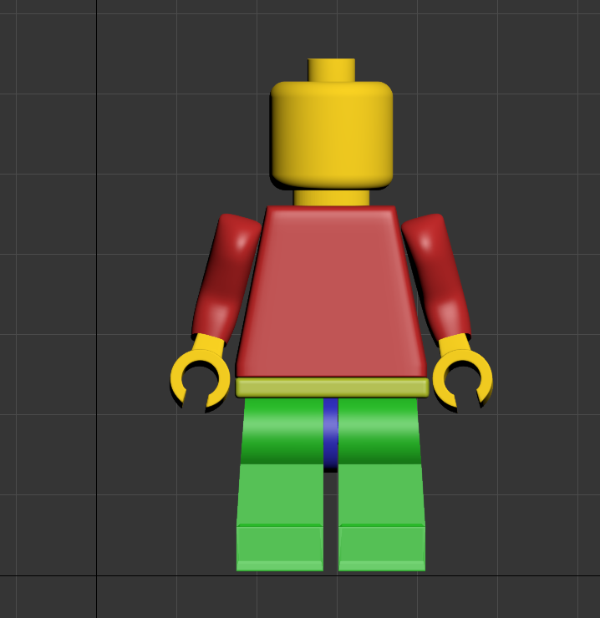as you can see from the screenshot below showing the Lego person I have created with variety of different colours in my Tutorials. I will be using this Lego figure in my group project as part of the Character inside the car. I will also be creating a car for my project with different type of animation to make look more interactive and allow users to navigate through the car.

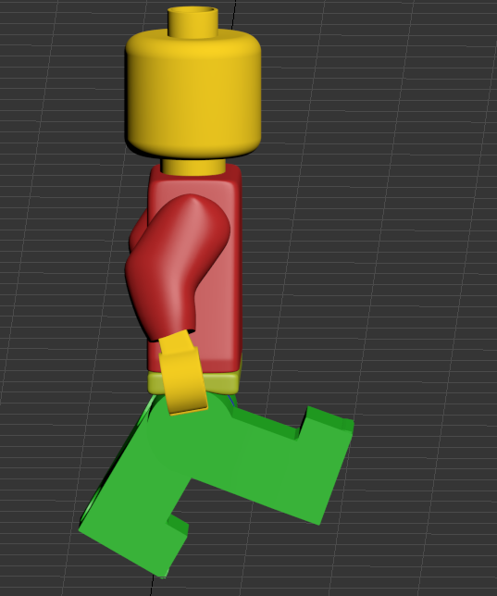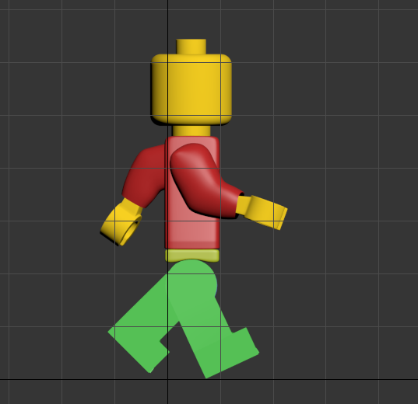

As you can see from the screenshots on the left showing the leg movement of the Lego figure I have created

As you can see from the screenshots on the left showing the arms and legs movement of the Lego figure I have created

The above screenshot shows the Lego figure that I have imported into unity software with a fully functioning moving animation. The animation part of the Lego figure I found quite challenging, so to make sure the animation part was done correctly, I had to edit each keyframes on the 3ds max to 25 keyframes to show the lowest position and 40 keyframes to give the highest point and also make sure that each arms and legs has the same rotation to make the animation run smoothly.

The problem that occur during exporting the project into the unity software was the animation part was not running as smooth as I was expecting it. In order to fix the animation issues, I had to fixed the keyframes and also the rotation for each arms and legs. The other problem I encounter was lack of contribution from some team members into the project due to attendance but I still manage to track down all the team member to work as a team on the project.

My role for part of the cw2 project is creating a car with inside viewing of the dashboard and also animating the object to make the wheels rotate smoothly and effectively. I will also create a garage with where the car will be kept safe from the dangers and when user click start on the object it will then move the object from one place to another also allowing users to switch on/off the lights of the cars. So far, I have not implemented the design for this part but below screenshot shows how the design will look like. I have also contributions to the group file where I had to describe the features of what the car object will have and also talked more about the UI and animation which are more important to the project

